**Section 2.3—Linear Functions and Slope**

**Slope**: measures how steep a line is; ratio of vertical change to horizontal change; rise over run

$$m=\frac{y_{2}-y_{1}}{x_{2}-x_{1}}$$

**Example**: Find the slope of the line passing through each pair of points.

$\left(-3,4\right)\&\left(-4,2\right)$

$\left(4,-2\right)\&\left(-1,5\right)$

**Four Possibilities for the Slope of a Line**:

* positive slope: line rises from left to right
* negative slope: line that falls from left to right
* zero slope: horizontal line
* undefined slope: vertical line

**Point Slope Form of an Equation**:

* (x1, y1) is a point on the line
* m is the slope of the line

**Example**: Write the point-slope form of the equation of the line with slope 6 that passes through the point $\left(2,-5\right)$. Then solve for y.

**Example**: Write the point-slope form of the equation of the line passing through the points $\left(-2,-1\right)$ and $\left(-1,-6\right)$. Then solve for y.

**Slope Intercept Form**: $y=mx+b$

* m represents the slope
* b represents the y-intercept

**Graphing y = mx + b using the slope and the y-intercept**.

1. Plot the y-intercept; $\left(0,b\right)$
2. Get to the second point by using *m* to determine how much to “rise” and how much to “run;” STARTING AT THE Y-INTERCEPT.
3. Draw a line through the two points.

**Example**: Graph the linear function $f(x)=\frac{3}{5}x+1$

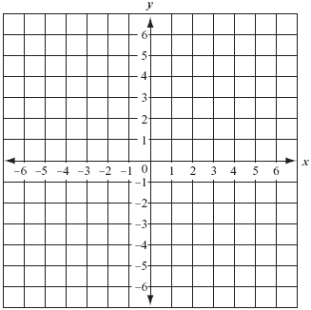

**Equation of a Horizontal Line**: $y=b$

* Horizontal lines have a slope of zero.

**Equation of a Vertical Line**: $x=a$

* Vertical lines have a slope that is undefined.

**Example**: Graph the following.







$y=-3$

$x=-3$

**General Form of an Equation**: $Ax+By+C=0$, both A and B cannot be 0

**Example**: Find the slope and y-intercept of the line whose equation is $3x+6y-12=0$. Then use those to graph the line.



**Using Intercepts to Graph Ax + By + C = 0**

1. Find the x-intercept. Let $y=0$ and solve for x. Plot that point.
2. Find the y-intercept. Let $x=0$ and solve for y. Plot that point.
3. Draw a line through the two points.

**Example**: Graph $3x-2y-6=0$ using intercepts.



**Summary of Equations of Lines**

|  |  |
| --- | --- |
| Point-Slope Form | $$y-y_{1}=m(x-x_{1})$$ |
| Slope-Intercept Form | $y=mx+b;$ $f(x)=mx+b$ |
| Horizontal Line | y = b |
| Vertical Line | x = a |
| General | Ax + By + C = 0 |